  SAVE OUR HISTORIC GASHOLDERS !  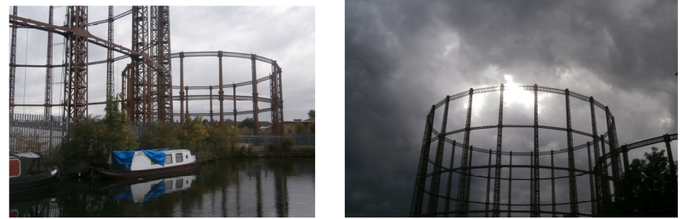  INDUSTRIAL HERITAGE ALERT!!  Three of our iconic gasholders are at serious risk of demolition in Tower Hamlets. Two of them dominate the open skyline alongside the Regent's Canal in Bethnal Green and the third one is a prominent landmark in Poplar.  We must ensure that these structures are all added to the local list, to protect them against demolition. Otherwise there will soon be nothing standing anywhere near the canal to connect ourselves – or future generations – with our industrial past. In 2020 we are due to celebrate the bi-centenary of the opening of the Regent's Canal, but if we don't act now there will be nothing left in London to remind us why the canal was built in the first place.  Please visit friendsofregentscanal.org for further information and for links to two petitions organised by the East End Waterway Group.  Alternatively, send an e-mail to friendsregentscanal@gmail.com |  |  | SAVE OUR HISTORIC GASHOLDERS !  INDUSTRIAL HERITAGE ALERT!!  Three of our iconic gasholders are at serious risk of demolition in Tower Hamlets. Two of them dominate the open skyline alongside the Regent's Canal in Bethnal Green and the third one is a prominent landmark in Poplar.  We must ensure that these structures are all added to the local list, to protect them against demolition. Otherwise there will soon be nothing standing anywhere near the canal to connect ourselves – or future generations – with our industrial past. In 2020 we are due to celebrate the bi-centenary of the opening of the Regent's Canal, but if we don't act now there will be nothing left in London to remind us why the canal was built in the first place.  Please visit friendsofregentscanal.org for further information and for links to two petitions organised by the East End Waterway Group.  Alternatively, send an e-mail to friendsregentscanal@gmail.com

