FRIENDS OF REGENT’S CANAL
PRE-MEETING REPORT.
March 2017

Summary.
2017 is going to be another challenging year for promoting and protecting the Regent's Canal.
In theory nothing could be easier than promoting a colourful, tranquil green corridor that serves as an escape from the bustle of city life, but in practice it can be an uphill task. A lot of pedestrians and water-borne tourists are giving the Regent's Canal a wide berth owing to conflicts with cyclists and overcrowded moorings, and despite the many attractions of London and its waterways, Black Prince decided in 2016 to suspend its boat hire holidays in this region.
However, the towpath is becoming much safer as natural surveillance increases and new visitors are making use of it, but we are still a long way from luring back the dog walkers and other pedestrians who perceive it as a racetrack. Hopefully things should start to improve for canal tourism if CRT's London Mooring Strategy is allowed to accelerate to the point where visitors will feel more confident in being able to find or book moorings.
Our role of protecting the canal is more demanding than ever as developers compete with each other to block out what is left of natural daylight. One by one, wharves, heritage landmarks and open spaces are disappearing and even the ones that remain are being distorted out of recognition. Planning applications continue to consume most of our energy because they tend to arrive without warning, we have limited time to coordinate any responses and they comprise hundreds of pages. Unfortunately, their impact is usually irreversible and they can threaten the canal's functional future as well as its current look and feel.
We have a duty to challenge all proposals that affect the canal and its environs and as an independent group we are in a strong position to do this without conflicts of interest.
Meanwhile, the minimum we can do is to explore as much of the canal as possible while it is still here to enjoy and of course to capture the existing scenes on camera for posterity.

Festivals and celebrations

Cavalcade
The annual 3-day festival at Little Venice runs from 29th April to 1st May. The organisers are still looking for volunteers. (See Ref 1).

Rickmansworth
This festival runs on 20th and 21st May. (See Ref 2)

Angel Canal Festival
This runs on Sunday 3rd September
We are actively trying to recruit volunteers at every level to ensure the continuity of this important event.
The Friends of Regent's Canal will have a stall and we welcome any advance help in preparing displays.

Regent's Canal bi-centenary
The main celebration will be in August 2020, to mark the anniversary of the opening of the canal, but there will also be opportunities between now and then to recognise the completion of major milestones.

New projects

Electricity bollards in Islington
Islington Council has secured some funding from DEFRA to work jointly with the CRT to install electricity bollards at the Noel Road visitor moorings and at the popular moorings by Tiber Gardens. Technical details are still under discussion, to evaluate the type of electrical equipment that will support heating systems. The aim is to declare these locations as smoke-free zones where moored boats will not be permitted to burn any fuel.

King's Cross community project
We have been approached by some historians who are running a lottery-funded heritage project known as "King's Cross Story Palace" that will gathering stories from King's Cross over the past 100 years. (See Ref 3). If anybody in our network can assist with this project then please make contact with Jan Wood (janet.wood@historypin.org).

London Waterways Projects - Bins by boat
A social enterprise known as the London Waterways Projects has begun a trial to collect boaters' litter by boat. (See Ref 4)

London Waterways Projects - Affordable moorings
This social enterprise has started to provide affordable moorings to community-oriented boaters. (See Ref 5)

Ongoing issues

Pollution on towpath
For several years there have been complaints about wood smoke entering canalside homes, but this year we have also started to receive complaints from towpath walkers. Fortunately this has only been an issue on severely cold days but it was sufficient to attract the attention of air quality campaigners and the local press.

Towpath cycling
We are still receiving complaints about aggressive cyclists on the towpath and a number of canal users feel that the only solution to the problem is a total ban on cycling. Clearly this is not on any authorities' agenda, given the amount of investment in towpath resurfacing, but it is a problem that is not going away. As a starting point we urge the authorities and cycle campaign groups to recognise the extent of the problem. It seems a terrible shame that some of the potential visitors who would really appreciate the canal environment are being deterred from using it at all.

Mooring Capacity
There can be little doubt that the Regent's Canal's capacity for moored boats has been exceeded. This is evident through the triple mooring in King's Cross and the number of boats tied to railings, lock landings and near bridge holes.
There are calls (from more than one boating group) for the CRT to provide additional mooring rings, but unless the CRT can control future influx of boats into London, capacity could be exceeded again within a few weeks. One of the causes of the overcrowding problem is ill-informed reporting in regional and national publications that claim that the housing crisis can be resolved in one fell swoop through purchasing or borrowing a boat.
We will have an opportunity to discuss mooring capacity at our meeting on 22nd March. For some crude statistics see our boat density charts (Tables 1 and 2) that illustrate the distribution of boats across the five boroughs.

Pontoons at Bluebell Moorings
We have received complaints about congestion above Acton's Lock in Hackney. This is because the navigational channel was severely narrowed when the pontoons were installed at the new Bluebell Moorings. Unfortunately these are semi-permanent fixtures so it is not an easy matter to reconfigure anything, but this should serve as a warning to any planners who are thinking of replicating this design elsewhere.

Litter
This is an ongoing problem and the IWA has reported that councils have reduced the number of litter bins. Fortunately there are groups of volunteers (e.g. the Lower Regent's Coalition and London Canal Volunteers) who take part in litter clearance exercises, but it is about time we started to address the root cause of the litter problem as well as reacting to it.

Planning applications

Bangor Wharf (Camden)
We objected strongly to the first application a year ago and the council swiftly refused it, citing 18 reasons. This second application is very similar to the first and should attract the same strength of opposition as the first one. It is very disturbing that the applicant has chosen not to offer any significant compromises while threatening to appeal the previous decision and while halving the ratio of affordable homes on offer. (For details and context see Ref 6).

Regent's Wharf (Islington)
At our public meeting in September we were given a presentation by the architects and our reactions at the time were relatively neutral. However, the detailed designs have evolved into a much bulkier canal frontage than we had anticipated and several groups have lodged objections. This plan is now going to be resubmitted in a few weeks. The Islington Society has expressed serious concerns about breaches of council guidelines in this conservation area and the CBOA (Commercial Boat Operators Association) has corrected some misunderstandings about the canal's suitability for construction traffic. (For details and context see Ref 7).

Ted Baker site (Big Ugly Brown Building)
There are plans for a massive redevelopment of this site. The council arranged a presentation earlier this month (see Ref 8) and we still have an opportunity to try to influence the design before any application is submitted.

Morrisons site (Camden)
There are proposals for a major development. This does not touch the canal but since the canal is within its geographical range we are in discussion with the developers to explore ideas for S106 contributions.

Somers Town Bridge
This bridge will cut across St Pancras Lock and Camley Street. It has already been approved and construction is underway. Unfortunately it will block some popular views along the canal and has resulted in loss of a community area in the wildlife park, but on the plus side it might encourage more people to visit and appreciate the nature reserve. (See Ref 9)

Paddington floating garden
Westminster council has granted permission to yield part of Paddington Basin for a five-year project that will host a floating garden. This will no doubt attract curious visitors to an otherwise sterile location, but we cannot afford to replicate this idea elsewhere in London because it will result in a net loss of valuable water space.

Administration of our group
We welcome contributions for our website, our Facebook group and our Twitter account. Especially photographs.
It would be useful to hold some ad-hoc meetings to supplement our scheduled public meetings. Possible venues include the new Plaquemine Lock pub (formerly the Prince of Wales) and the re-opened cafe at City Road Lock

References
Ref 1
https://www.waterways.org.uk/events_festivals/canalway_cavalcade/volunteer
Ref 2
http://www.rwt.org.uk/festival/
Ref 3
http://friendsofregentscanal.org/events/2017/2017-03-22/KX-heritage/Kings-Cross-Story-Palace-flyer-A4.pdf
Ref 4
http://www.londonwaterwaysprojects.co.uk/bins-by-boat/
Ref 5
http://www.londonwaterwaysprojects.co.uk/moorings/
Ref 6
http://friendsofregentscanal.org/features/property-devt/Bangor-Wharf/Save-Bangor-Wharf.html
Ref 7
http://friendsofregentscanal.org/features/property-devt/Kings-Cross/Regents-Wharf/plans.html
Ref 8
http://friendsofregentscanal.org/features/property-devt/St-Pancras-Way/Ted-Baker-site/council-drop-in.html
Ref 9
http://friendsofregentscanal.org/features/property-devt/Kings-Cross/Camley-St-bridge/before-after.html
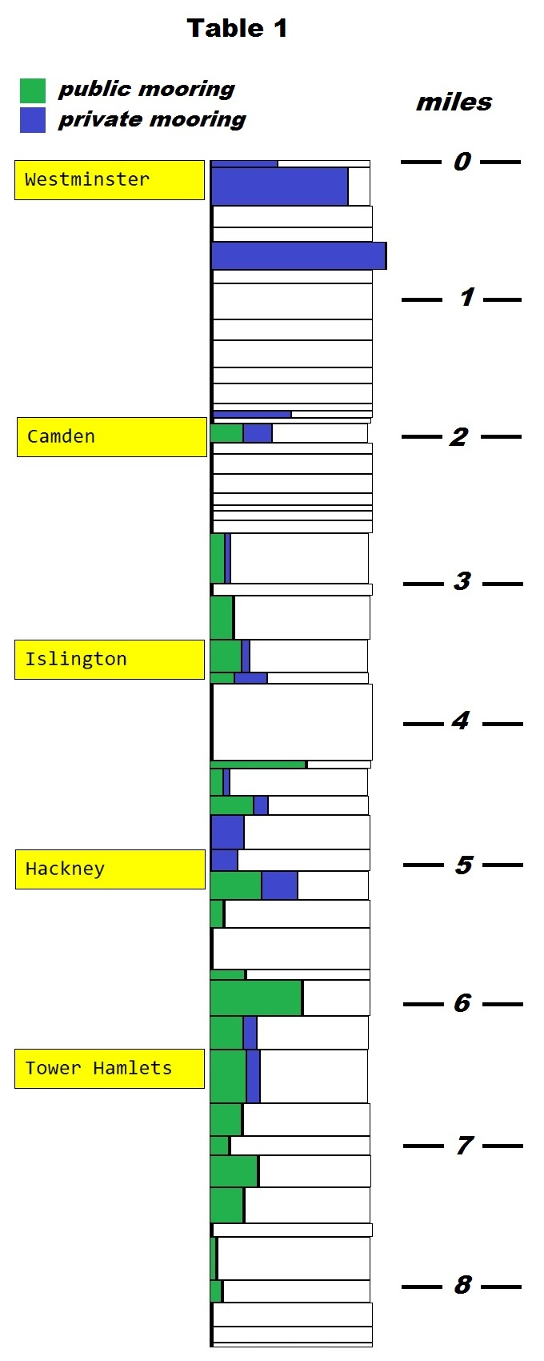
Table 2
The table below is a rough guide to the number of moored boats that can be accommodated on the Regent's Canal.
yds = length of canal stretch in yards
TC = towpath casual moorings (assume single mooring)
TV = towpath visitor moorings
TP = towpath private moorings
OC = offside casual moorings
OV = offside visitor moorings
OP = offside private moorings

 | yds | TC | TV | TP | OC | OV | OP
Harrow Road to Warwick Road | 90 |  |  | 5
Warwick Road to Edgware Road | 480 |  |  | 37 |  |  | 18
Edgware Road to Maida Hill Tunnel | 270
Maida Hill Tunnel to Lisson Grove | 185
Lisson Grove to footbridge | 350 |  |  |  |  |  | 51
footbridge to Park Road | 175
Park Road to Charlbert Bridge | 455
Charlbert Bridge to Macclesfield Bridge | 260
Macclesfield Bridge to Primrose Hill Bridge | 340
Primrose Hill Bridge to Zoo footbridge (W) | 205
Zoo footbridge (W) to Zoo footbridge (E) | 250
Zoo footbridge (E) to St Marks bridge | 90
St Marks bridge to Prince Albert Road | 90 |  |  |  |  |  | 5
Prince Albert Road to Regents Park Road | 75
Regents Park Road to Gloucester Ave | 245 |  | 7 |  |  |  | 6
Gloucester Ave to Oval Rd | 145
Oval Rd to Camden High St | 255
Camden High St to Kentish Town Rd | 240
Kentish Town Rd to Camden St | 150
Camden St to Camden Rd | 70
Camden Rd to Royal College Street | 125
Royal College Street to St Pancras Way | 160
St Pancras Way to Camley Street bridge | 630 | 8 |  |  |  |  | 3
Camley Street bridge to St Pancras Lock | 150
St Pancras Lock to York Way | 555 | 5 |  |  | 6
York Way to Caledonian Road | 410 | 11 |  |  |  |  | 3
Caledonian Road to Muriel Street | 145 | 3 |  |  |  |  | 4
Islington Tunnel | 960
Colebroke Row to Danbury Street | 100 |  | 8
Danbury Street to Wharf Road | 345 | 4 |  |  |  |  | 2
Wharf Road to Packington bridge | 245 | 9 |  |  |  |  | 3
Packington bridge to New North Road | 430 |  |  |  |  |  | 12
New North Road to Bridport Road | 270 |  |  |  |  |  | 6
Bridport Road to Whitmore Road | 365 | 16 |  |  |  |  | 11
Whitmore Road to Kingsland Road | 350 | 4
Kingsland Road to Haggerston bridge | 520 | 1
Haggerston bridge to Queensbridge Road | 135 | 4
Queensbridge Road to Goldsmith Road | 455 | 23 |  |  | 12
Goldsmith Road to Mare Street | 425 | 12 |  |  |  |  | 5
Mare Street to Bonner Bridge | 675 | 21 |  |  |  |  | 8
Bonner Bridge to Old Ford Road | 410 | 11
Old Ford Road to Roman Road | 245 | 4
Roman Road to footbridge | 400 | 16
footbridge to Mile End Road | 455 | 13
Mile End Road to Solebay Street | 170
Solebay Street to Rhodeswell Road | 545 | 1 | 2
Rhodeswell Road to railway bridge | 285 | 3
railway bridge to Salmon Lane | 305
Salmon Lane to Commercial Road | 200
Commercial Road to Limehouse | 60
Totals | 14945 | 169 | 17 | 42 | 18 | 0 | 137

