

PUBLIC MEETING, Wed 22nd March 2017

Meet fellow canal supporters, hear about the latest issues
and find out how you can help to protect YOUR canal
against unsympathetic changes.

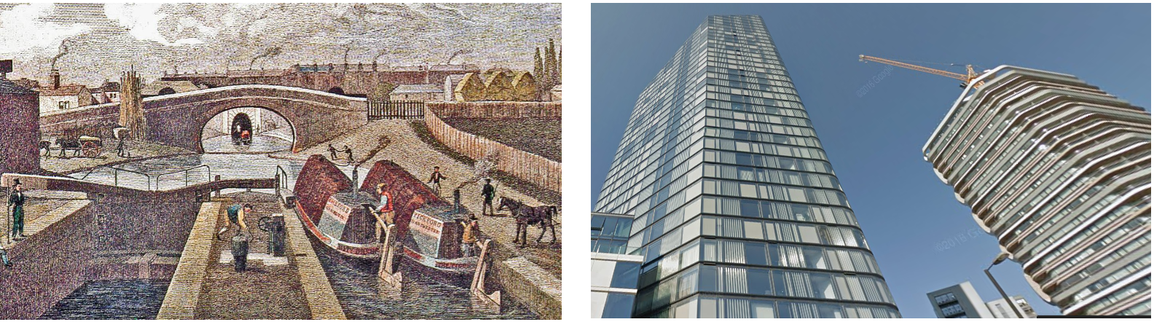

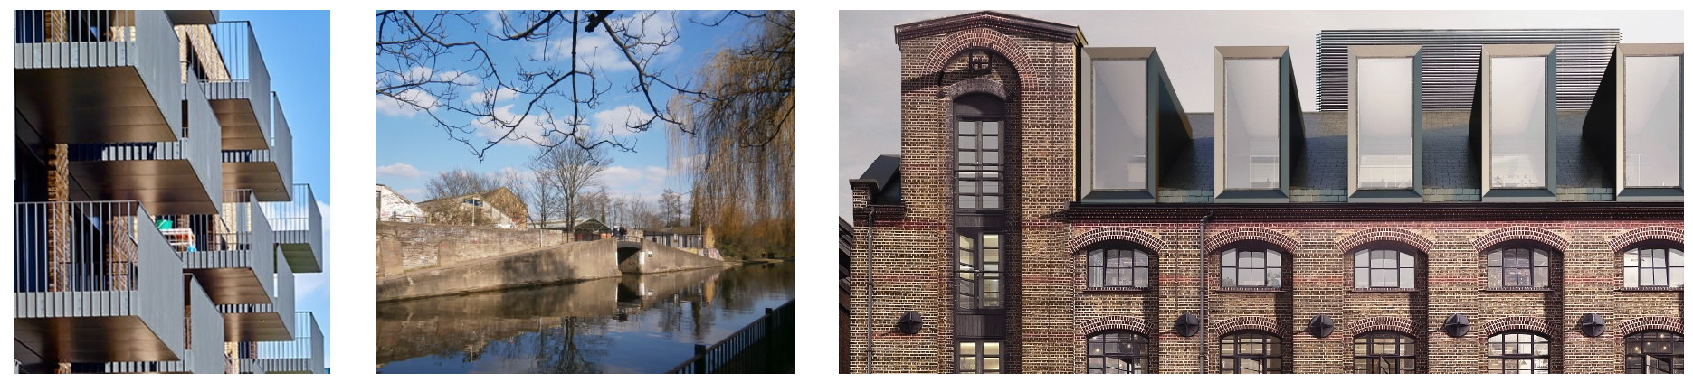

7pm to 9pm
London Canal Museum,
12-13 New Wharf Road,
N1 9RT
(near King’s Cross)

www.friendsofregentscanal.org

