

PUBLIC MEETING, Wed 30th Mar 2016

Can we protect this? |  |  |  |  | … and prevent this?
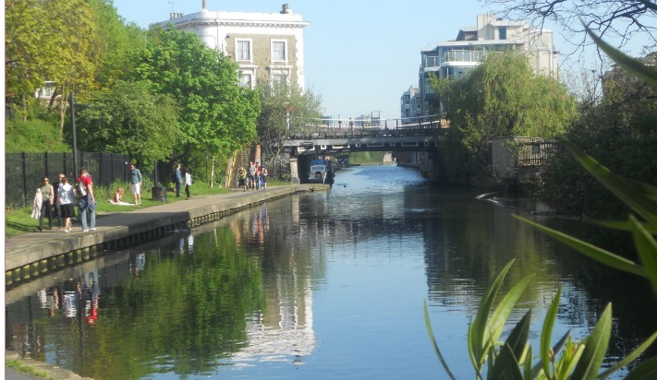 |  |  |  |  | 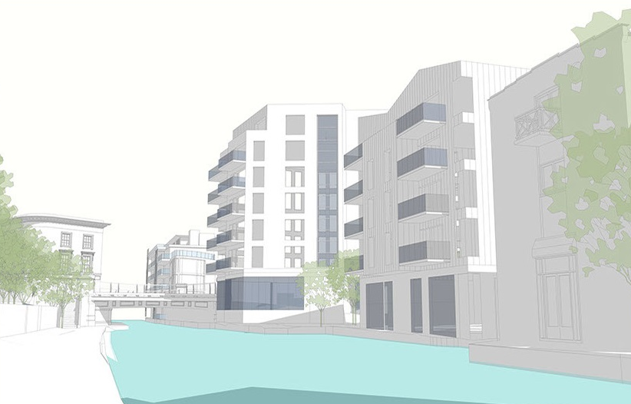
 | Meet fellow canal supporters and find out what we are gaining and losing along London’s waterways
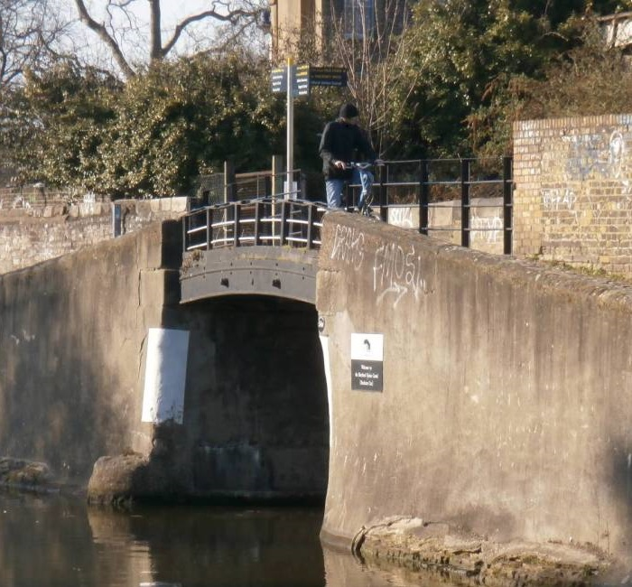 |  |  | 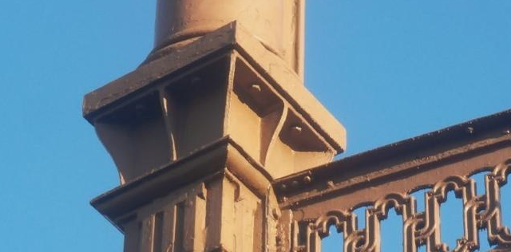 |  |  | 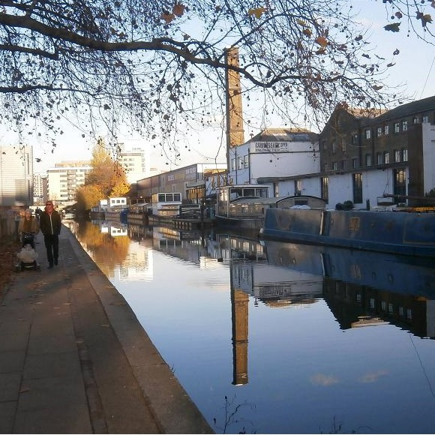
7pm to 9pm
London Canal Museum,
12-13 New Wharf Road,
N1 9RT
(near King’s Cross)

